**Rolly Ball**

There are two game modes, both available from the intro screen.

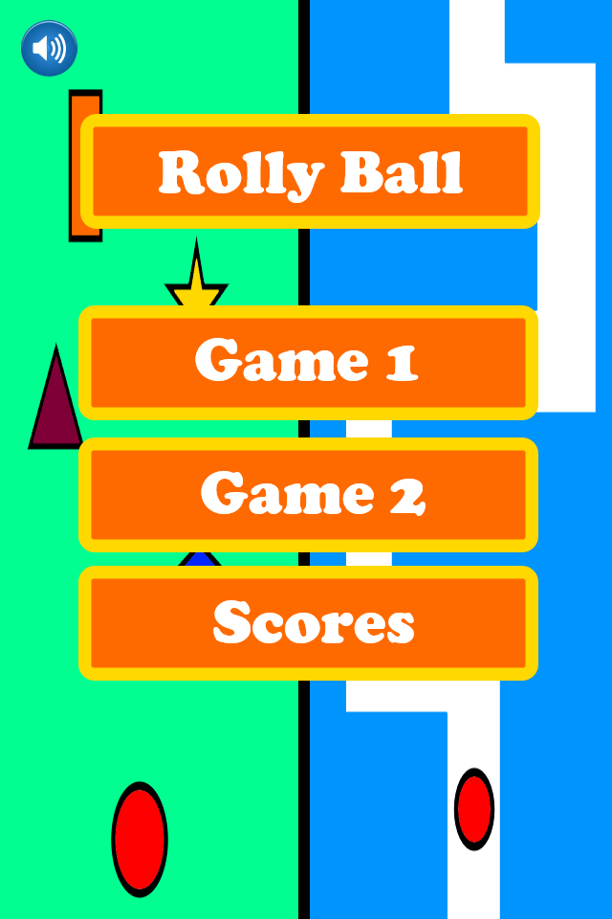

**Game 1 –** Dodging falling objects by moving left and right, using a swiping motion.

|  |  |
| --- | --- |
|  | * You are the ball at the bottom, you swipe left and right to avoid the other falling shapes. * Difficulty can be selected before playing. * Objects are dropped randomly, there are more objects moving at a higher speed with the higher difficulties. * Score increases with every shape dodged. * There will be collectables that occasionally drop to increase score. |

**Game 2 –** Navigate the ball through the maze

|  |  |
| --- | --- |
|  | * Navigate the maze by swiping the ball left/ Right. * The maze moves down towards you. * The speed of the maze increases as time advances. * Collectables will be in harder to reach areas. * Again there are three difficulties that determine the starting speed of the maze. * The score increases with distance travelled in the maze (making all difficulty scores comparable). |

**Extra Features**

* Achievements
* Swipe left and right to change menu screens
* Global high scores
* Extra levels for game mode 2